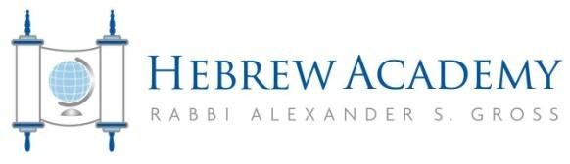

Dear Parents,
Summer is fast approaching and that means sun, sand and summer reading!
One of the primary goals of the Hebrew Academy high school English department is to instill a love for literature within students. With that in mind, we have compiled a summer reading list to ensure that student reading will be not only intellectually stimulating and educational, but pleasurable as well. The list of required and choice books strikes the right balance between academically challenging and entertaining material.
Students of incoming grade levels 9th through 11th will be responsible for reading one required book and one choice book and completing an assignment. Incoming seniors will read a required book and write a first draft of their college essay in order to get a head start on the college application process.
We also encourage parents to participate by reading the books if you are so inclined, and engaging your children in discussions. Literature can often serve as an effective bridge to lively exchanges of ideas between adolescents and adults.
Happy reading, and please do not hesitate to contact me should you have any questions or suggestions concerning the reading list.
Have a great summer!
Leah Handwerger
English Department Chair
lhandwerger@rasg.org

