11th Grade American Literature College Prep
Summer Reading 2019

All incoming 11th grade students must read two books: one required book and one choice book.

REQUIRED BOOK: Red Moon by Benjamin Percy
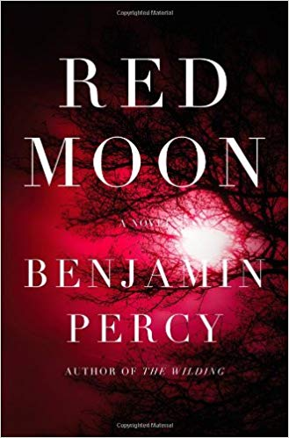

Assignment: Write a 3-4 page essay on each of the following story elements:

SETTING
- How is the modern setting in Red Moon altered from our modern reality?
- How is it similar?

CHARACTER
- How does this altered setting complicate life for the main character?
- What sets the main character off on his/her journey to fight back against this altered setting?
- What skill sets does he/she possess from their regular lives to help them fight this injustice and how do they use those skill sets?
- How does the main character go from regular citizen to hero?

PERSPECTIVE
- Choose a secondary character that ends up playing a major role.
- Name three major plot developments that propel this character from a minor character to a major one?
- Give two ways in which this secondary character differs from the main character?
- Give three examples of ways in which this secondary character proves more interesting than the main character and explain why for each.

FORMATTING
- This is a full essay which must answer all of these questions and contains proper grammar, spelling, mechanics, and transitions. As you write, remind yourself It’s an essay, not a reading comprehension assignment.
- Double spaced, 12-point, Times New Roman.
- Page numbers must appear at the upper right corner of each page.
- Your full name must appear on every page on the upper left hand corner.
- Please staple the essay.
- Hard copies only. Electronic copies will not be accepted.

INTEGRITY
This is an independent assignment. Students are not allowed to share essays or collaborate in any way, shape, or form. All of the information contained in your essays should be original thoughts, ideas, and observations. Any evidence of shared answers or information will result in a failing grade and disciplinary action for all involved parties that will weigh heavily on your average and reputation. Simply put: read the novels and write the essay on your own.

CHOICE BOOK: Select one of the following titles for your second book.

- Pure - Julianna Baggot

- Do Androids Dream of Electric Sheep - Philip K. Dick

- The Road - Cormac McCarthy

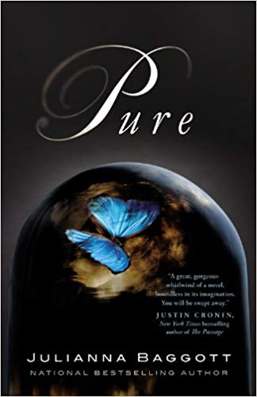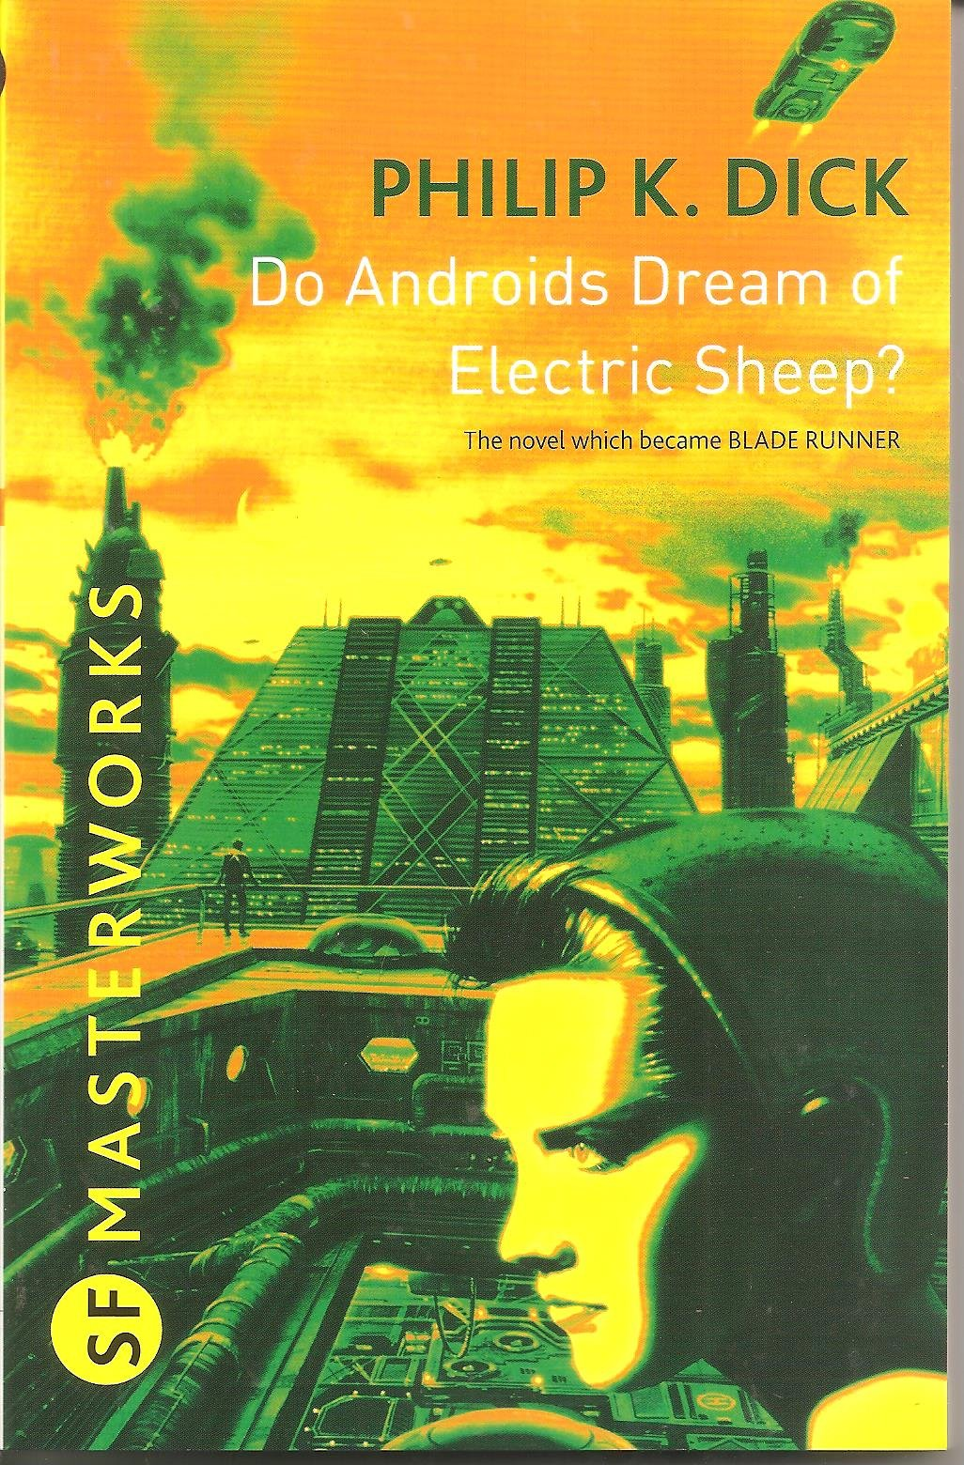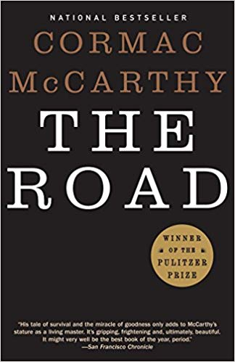

Assignment: As you read, annotate the following:

- Put a box around all new characters, dates, and places mentioned in the text
- Underline short passages or quotations that stand out to you
- Put a symbol in the margin if passages that might connect or do connect to major themes you’ve encountered in the book so far, including: setting, important characters, and differing points-of-view
- At the end of each chapter:
  - Write down 3-4 bullet points of summary
  - Write 1-3 questions that you have about the reading. These questions can be plot driven, but it’s better if they are about ideas rather than content.

NOTE: For this assignment, you are just annotating. There is no response paper involved. However, the first day of class you are expected to come in with your choice book annotated, which I will be checking for. This will be worth a grade and there will be no exceptions or extensions given. You will also be completing an in-class assignment that requires you to have a fully-annotated book.

