AP Literature Summer Reading 2019
Ms. Anna Ehrlich
aehrlich@rasg.org

Students enrolled in AP Literature read five short stories and three short plays this summer. Each reading has an accompanying annotation assignment detailed below.

American Short Fiction
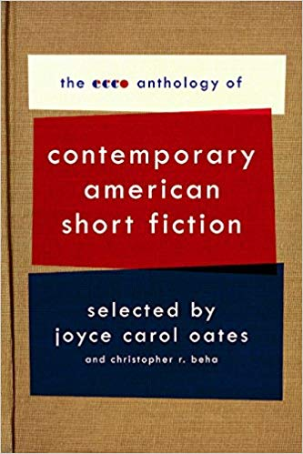
From The ECCO Anthology of Contemporary American Short Fiction selected by Joyce Carol Oates, students will read five short stories of their choice from the following list. These stories cover a variety of topics and capture the complex nature of the human experience. In addition to annotating according to the attached guidelines, students should seek to make connections between the main themes and conflicts of the stories. Students must be prepared to express these ideas in writing or discussion on the first day of school. We will use this book throughout the year, so it is essential that students keep track of their copy.

Please choose five stories from this list:
- Lobster Night by Russell Banks
- Poor Devil by Charles Baxter
- Mercy by Pinckney Benedict
- Death of the Right Fielder by Stuart Dybek
- To Those of You Who Missed Your Connecting Flights Out of O’Hare by Amy Hempel
- Emergency by Denis Johnson
- Baboons by Sheila Kohler
- On the Rainy River by Tim O’Brien

Three Theban Plays
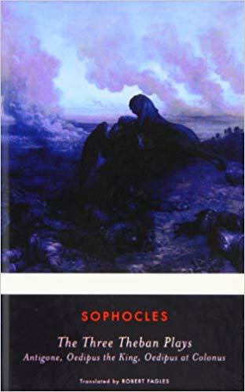

Students will also read Three Theban Plays by Sophocles. Students who have already read Antigone need only to review the work in preparation to read Oedipus at Colonus - it is the second play in the trilogy. In addition to following the included annotation guidelines, students should take note of irony in the plays. Everyone should be prepared to discuss specific passages in conjunction with irony on the first day of school.

Summer Reading Annotation Guidelines
As you read this summer, you will annotate your books following the guidelines below. This annotation grade will replace a summer reading writing assignment. On the first day of school, I will collect your books so that I can grade your annotations. To receive the highest grade possible, please follow the formatting guidelines:
- Put a box around all new characters, dates, and places mentioned in the text.
- Underline short passages or quotations that stand out to you.
- Put a symbol (I like to use a star, but whatever works is fine) in the margin of passages that might connect or do connect to major themes you’ve encountered in the book so far.
- At the end of each chapter:
  - Write down 3-4 bullet points of summary.
  - Write 1-3 questions that you have about the reading. These questions can be plot driven, but it’s better if they are about ideas rather than content.

Here’s how you will be graded:
A-range | B-range | C-Range | D-Range | F-range | Zero (no credit)
Student follows all guidelines perfectly. The entire book is annotated thoroughly. | Student follows the guidelines most of the time, but sometimes leaves out an element or leaves small parts of the book blank. | Student sometimes follows the guidelines, but often leaves out one of the elements or leaves large portions of the book blank. | Student rarely follows the guidelines and often leaves out one of the elements or leaves large portions of the book blank. | Student rarely follows the guidelines and often leaves out one of the elements and leaves large portions of the book blank. | Student did not complete the assignment.

You must present your book for credit on the first day of school. Preparation for class is essential for success, so you will not receive credit if you do not present your book. You can expect to be assessed on this reading in some format on the first day of class.

Questions? Email Ms. Ehrlich at: aehrlich@rasg.org

