10th Grade World Literature College Prep
Summer Reading 2019

Students in World Literature must read TWO books and complete ONE assignment.

REQUIRED BOOK

You MUST read the following book:
1. The Island of Dr. Moreau – H.G. Wells
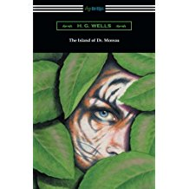

CHOICE BOOK

The second is a book of choice from the following list of graphic novels. You are only required to read ONE of these books.

- The Saga of The Swamp Thing; Book One - Alan Moore

- We 3 - Grant Morrison

- Days of Destruction, Days of Revolt - Chris Hedges and Joe Sacco

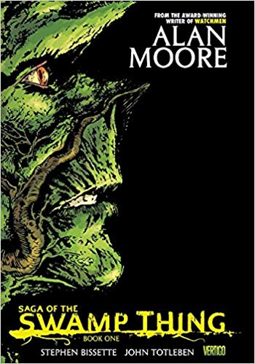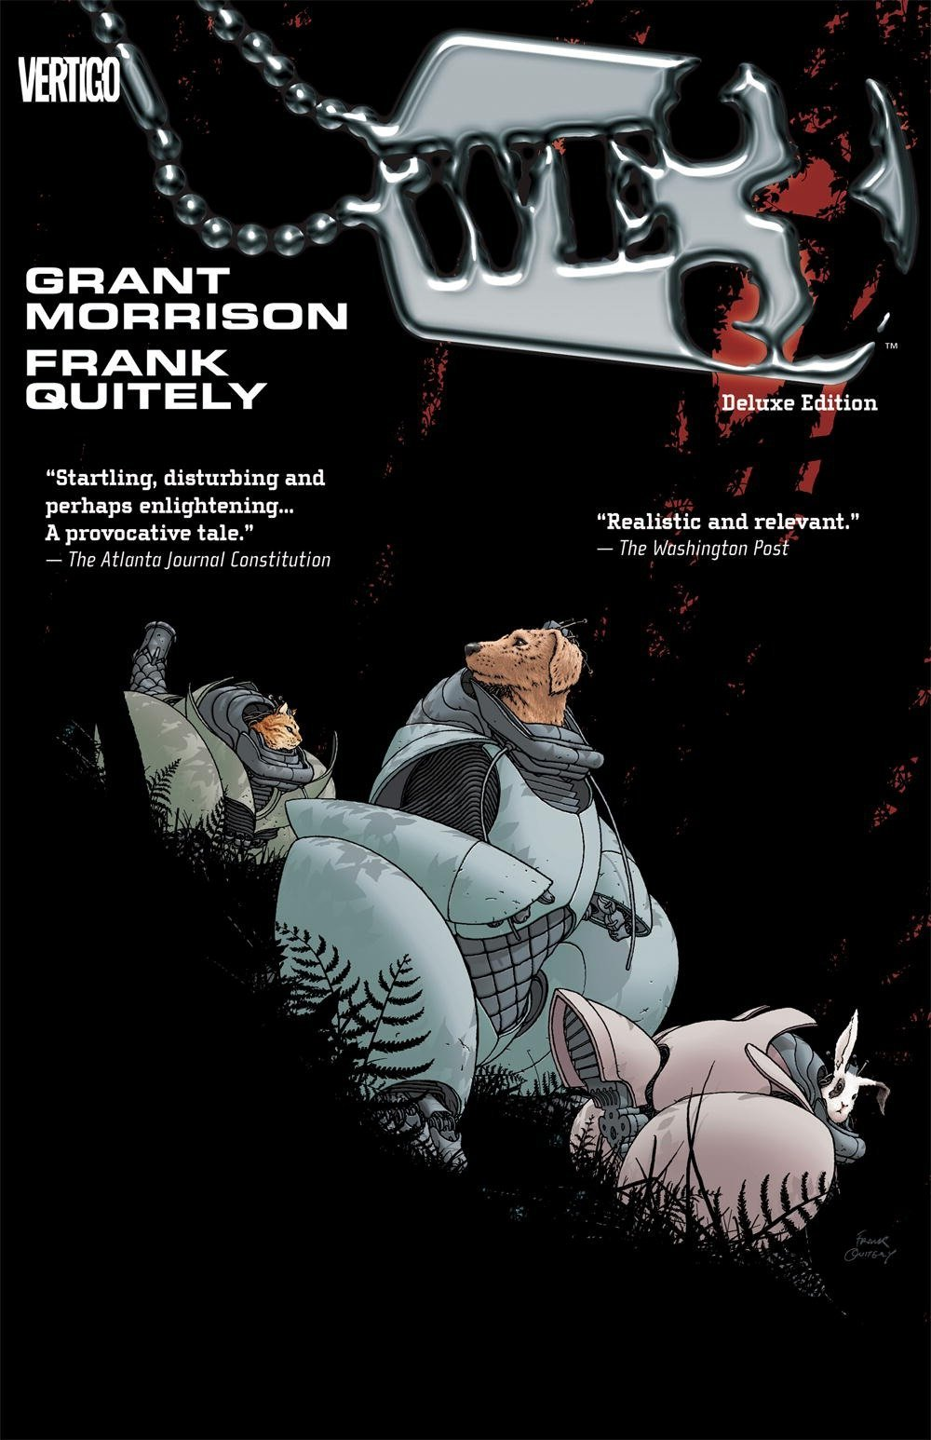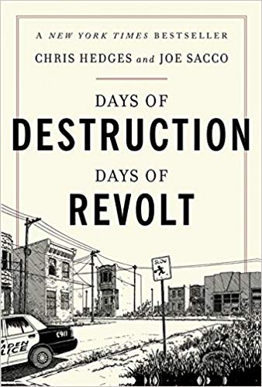

Assignment: All of these stories make a commentary about the environment. In a 3-4 page essay, you will compare The Island of Dr. Moreau to your book of choice by answering and expanding on the following prompts. Focus on the commentary each story makes on the state of the world and its environment.
- How has the environment been catastrophically impacted in both stories?
- How is man responsible for this impact on the environment?
- What was Wells trying to say about man taking experimentation too far?
- What evidence is there in your choice book that man has taken experimentation too far?
- How does the point-of-view character from the graphic novel you chose bring a different/unique perspective to their story in comparison to the point-of-view character in The Island of Dr. Moreau? How does the graphic novel format help shape and develop this unique view point?

READING A GRAPHIC NOVEL

If you’re unfamiliar with the format, watch this short video on how to read graphic novels. It includes definitions of panels, dialogue, bubbles, and narration.

https://www.youtube.com/watch?v=ABunuePPnrA

FORMATTING

- This is a full essay. Your full paper must answer all of these questions and contain proper grammar, spelling, mechanics, and transitions. As you write, remind yourself It’s an essay, not a reading comprehension assignment.
- Double spaced, 12-point, Times New Roman.
- Page numbers must appear at the upper right corner of each page.
- Your full name must appear on every page on the upper right hand corner.
- Please staple the essay.
- Hard copies only. Electronic copies will not be accepted.

INTEGRITY

This is an independent assignment. Students are not allowed to share essays or collaborate in any way, shape, or form. All of the information contained in your essays should be original thoughts, ideas, and observations. Any evidence of shared answers or information will result in a failing grade and disciplinary action for all involved parties that will weigh heavily on your average and reputation. Simply put: read the novels and write the essay on your own.

