12th Grade Honors Literature and Composition
Summer Reading 2019

Students in 12th grade Honors English Literature must read one book, complete one assignment, and write one essay.
All students must write the Common Application Essay. The 2019-20 essay prompts can be found below. Choose your prompt and indicate your choice at the top of your essay. Your essay must be turned in to your teacher on the first day of class.
Required Reading: The Kite Runner, by Khaled Hosseini
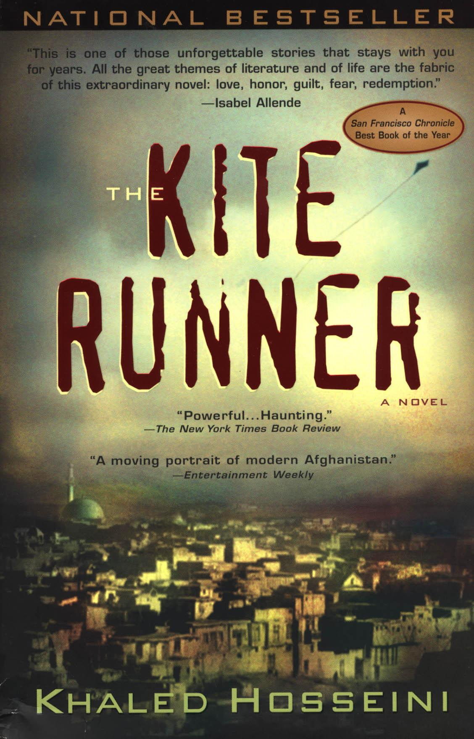
The unforgettable, heartbreaking story of the unlikely friendship between a wealthy boy and the son of his father’s servant, caught in the tragic sweep of history, The Kite Runner transports readers to Afghanistan at a tense and crucial moment of change and destruction. A powerful story of friendship, it is also about the power of reading, the price of betrayal, and the possibility of redemption; and an exploration of the power of fathers over sons—their love, their sacrifices, their lies.
Since its publication in 2003 Kite Runner has become a beloved, one-of-a-kind classic of contemporary literature, touching millions of readers, and launching the career of one of America's most treasured
writers. (from Amazon)

Please follow these guidelines as your assignment:
As you read The Kite Runner, you will annotate your book following the guidelines below. This annotation grade will replace a summer reading writing assignment. On the first day of school, I will collect your books so that I can grade your annotations. To receive the highest grade possible, please follow the formatting guidelines:
- Put a box around all new characters, dates, and places mentioned in the text.
- Underline short passages or quotations that stand out to you.
- Put a symbol (a star, an arrow, or whatever works for you) in the margin of passages that might connect or do connect to major themes you’ve encountered in the book so far.
- At the end of each chapter:
  - Write down 3-4 bullet points of summary.
  - Write 1-3 questions that you have about the reading. These questions can be plot driven, but it’s better if they are about ideas rather than the narrative itself.

Here’s how you will be graded:
A-range | B-range | C-Range | D-Range | F-range | Zero (no credit)
Student follows all guidelines perfectly. The entire book is annotated thoroughly. | Student follows the guidelines most of the time, but sometimes leaves out an element or leaves small parts of the book blank. | Student sometimes follows the guidelines, but often leaves out one of the elements or leaves large portions of the book blank. | Student rarely follows the guidelines and often leaves out one of the elements or leaves large portions of the book blank. | Student rarely follows the guidelines and often leaves out one of the elements and leaves large portions of the book blank. | Student did not complete the assignment.

You must present your book for credit on the first day of school. Preparation for class is essential for success, so you will not receive credit if you do not present your book. You can expect to be assessed on this reading in some format on the first day of class.

All incoming seniors are also required to write an essay for the Common Application. This essay must be typed, double-spaced, and no more than 650 words. (The application won’t accept a response shorter than 250 words, either.) Essays will be collected on the first day of class.
Common Application Essay:
Choose one of the following five prompts for your essay.
1. Some students have a background, identity, interest, or talent that is so meaningful they believe their application would be incomplete without it. If this sounds like you, then please share your story.
2. The lessons we take from obstacles we encounter can be fundamental to later success. Recount a time when you faced a challenge, setback, or failure. How did it affect you, and what did you learn from the experience?
3. Reflect on a time when you questioned or challenged a belief or idea. What prompted your thinking? What was the outcome?
4. Describe a problem you've solved or a problem you'd like to solve. It can be an intellectual challenge, a research query, an ethical dilemma - anything that is of personal importance, no matter the scale. Explain its significance to you and what steps you took or could be taken to identify a solution.
5. Discuss an accomplishment, event, or realization that sparked a period of personal growth and a new understanding of yourself or others.
6. Describe a topic, idea, or concept you find so engaging that it makes you lose all track of time. Why does it captivate you? What or who do you turn to when you want to learn more?
7. Share an essay on any topic of your choice. It can be one you've already written, one that responds to a different prompt, or one of your own design.
For tips on writing your college essay, check out the following link:
http://collegeapps.about.com/od/essays/a/common-application-essay-prompts.htm

