11th Grade AP English Language and Composition

Summer Reading 2019-2020

AP English Language and Composition is quite different from the English classes you have taken over the years. Instead of analyzing the literary aspects of a work, we will be discussing the rhetorical strategies the author employs to convey his or her message. Instead of focusing on fiction, poetry, and drama, we will focus primarily on non-fiction essays and speeches. Instead of looking at a work of literature as a product, we study writing as a process. Ideally, by the end of the course you will be highly proficient, highly persuasive writers.

To prepare for the course this summer, you will read Thank You for Arguing, by Jay Heinrichs. It’s a pop-culture packed primer to persuasive argument. We will refer back to examples from this book throughout the year. After reading this text, you will write a book review.

In addition to this book, you will also read several essays about the craft of writing. You will choose three texts from the choices below and write a synthesis essay, using these sources to support your argument.

Book:
Heinrichs, Jay. Thank You for Arguing: What Aristotle, Lincoln, and Homer Simpson Can Teach Us about the Art of Persuasion. Third ed. New York: Three Rivers, 2017. Print. (978-0804189934)
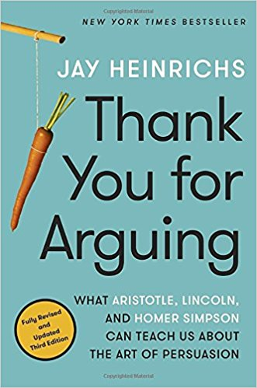

Assignment #1: Argument Essay
Write a five paragraph book review essay for the above text. Your audience is future AP English Language and Composition students. Do you recommend it to AP English Language and Composition students? Is it a valuable text for teaching the art of persuasion? Argue for or against using this text in an AP English Language and Composition class. Support your argument with three reasons, making specific reference to the above text.

Assignment #2: Synthesis Essay
Many authors have written about their writing process; some focus on what inspires them, while others discuss the formal aspects of their work.

Carefully read the following seven essays listed below, then synthesize information from three of these essays. Incorporate the information you have chosen from the three texts into a coherent, well-developed essay that identifies the key issues that you should consider in your own writing.
Your argument should be the focus of your essay. Use the sources to develop your argument and explain the reasoning for it. Avoid merely summarizing the sources. Indicate clearly which sources you are drawing from, whether through direct quotation, paraphrase, or summary.

Essays:
Orwell, George. “Why I Write.”
Didion, Joan. “Why I Write.” (Alternate source)
Gilbert, Elizabeth. “Thoughts on Writing.”
King, Stephen. "Everything You Need to Know About Writing Successfully - in Ten Minutes"
Gaiman, Neil. “Where do You Get Your Ideas?”
Letham, Jonathan. “The Ecstasy of Influence.”
Smith, Zadie. “The Rise of the Essay.”

Questions? Email Mrs. Handwerger lhandwerger@rasg.org

