9th Grade Honors Summer Reading 2019
Ms. Anna Ehrlich
aehrlich@rasg.org

All incoming 9th grade honors students must read and annotate one required book (guidelines below) and one book of choice from the list below.
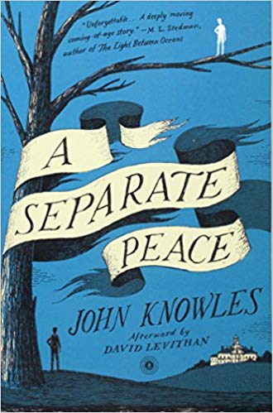
Required:
A Separate Peace by John Knowles

Narrator and protagonist Gene returns to the Devon School in New Hampshire that he attended with his friend Phineas. The story shifts back 15 years to the boys’ school days, and Gene reflects on his time as a student. While he is happy to recall some memories, he is forced to confront feelings of guilt and remorse that he still carries with him.

Please follow these guidelines as your assignment:
As you read this summer, you will annotate your books following the guidelines below. This annotation grade will replace a summer reading writing assignment. On the first day of school, I will collect your books so that I can grade your annotations. To receive the highest grade possible, please follow the formatting guidelines:
- Put a box around all new characters, dates, and places mentioned in the text.
- Underline short passages or quotations that stand out to you.
- Put a symbol (I like to use a star, but whatever works is fine) in the margin of passages that might connect or do connect to major themes you’ve encountered in the book so far.
- At the end of each chapter:
  - Write down 3-4 bullet points of summary.
  - Write 1-3 questions that you have about the reading. These questions can be plot driven, but it’s better if they are about ideas rather than content.

Here’s how you will be graded:
A-range | B-range | C-Range | D-Range | F-range | Zero (no credit)
Student follows all guidelines perfectly. The entire book is annotated thoroughly. | Student follows the guidelines most of the time, but sometimes leaves out an element or leaves small parts of the book blank. | Student sometimes follows the guidelines, but often leaves out one of the elements or leaves large portions of the book blank. | Student rarely follows the guidelines and often leaves out one of the elements or leaves large portions of the book blank. | Student rarely follows the guidelines and often leaves out one of the elements and leaves large portions of the book blank. | Student did not complete the assignment.

You must present your book for credit on the first day of school. Preparation for class is essential for success, so you will not receive credit if you do not present your book. You can expect to be assessed on this reading in some format on the first day of class.

Questions? Email Ms. Ehrlich at: aehrlich@rasg.org

II. CHOICE BOOK: Select a book from the list below. You must be prepared to discuss on the first day of school.

Into Thin Air by Jon Krakauer
The story of a group of climbers, who were unexpectedly hit with a tragic storm while climbing Mt. Everest. A fascinating read.

Tuesdays with Morrie by Mitch Albom
A gripping memoir about mentorship, living with passion, and dying with grace. Albom reconnects with his professor Morrie Schwartz. On his deathbed, Morrie teaches him about what matters most: love.

Speak by Laurie Halse Anderson
High school freshman Melinda struggles with rejection after her friend group abandons her. As she navigates the new complex social scene, she learns how to grow despite immense challenges in and outside the classroom.

The Hate U Give by Angie Thomas
Angie Thomas’s debut novel follows the life of sixteen-year-old Star Carter in the wake of her best friend’s death. She constantly must shift between the poor neighborhood where she lives and the fancy suburban private school she attends. Caught in the Midst of the conflict surrounding the fatal shooting, Star must face the harsh and dissonant realities of her two worlds.

